IMU sensor data Configuration using MPU6050 as example

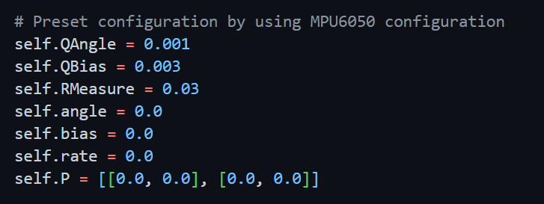

Illustration of Kalman Filter & Complementary Filter

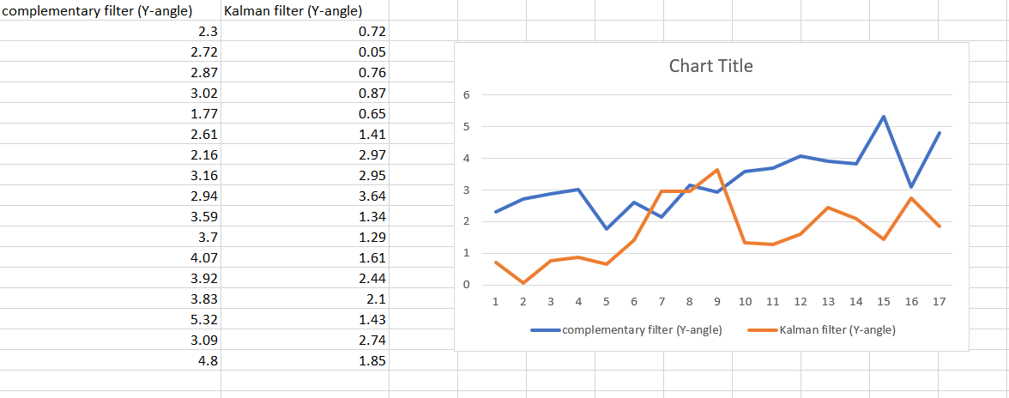

Result

The result show that the Kalman filter and complementary filter are able to provide a close range of result when combining the accelerometer data and gyroscope data together as a comparison. The team felt that the complementary filter is much simpler to implement however there are some limitations which is you can feed it only one measurement, and the output will be the same nature as the input and we might have to tune the response time ourself. Hence the team decided to go with Kalman filter algorithm which is more powerful and it uses the model to predict what will be the next state of the system given its current state in the future.